## ELF Input

### Standard Programming

Load the application as per requirement by selecting an appropriate ELF.

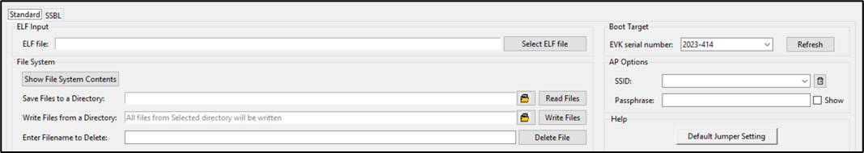

Figure 15: ELF input - Standard programming

### SSBL Programming

1. SSBL Image: Select the appropriate SSBL image file to be loaded onto boot partition.
2. ELF File: Load the application as per requirement by selecting an appropriate ELF.

For more information on SSBL programming, refer: Application_for_using_SSBL.pdf (*sdk_x.y/apps/ssbl/doc*).

**Note**: x and y in sdk_x.y refer to the SDK release package version.

Before SSBL programming, write the necessary files onto Talaria TWO. For more details on writing files onto Talaria TWO, refer section: Write Files.

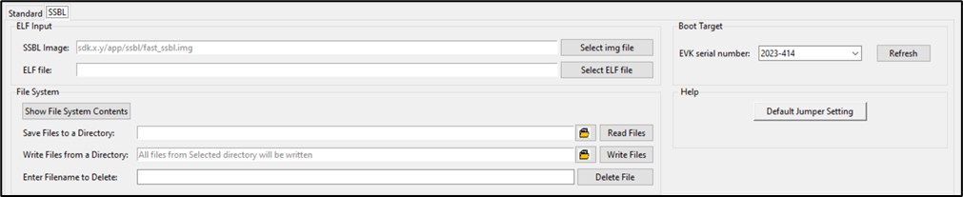

Figure 16: ELF input - SSBL programming